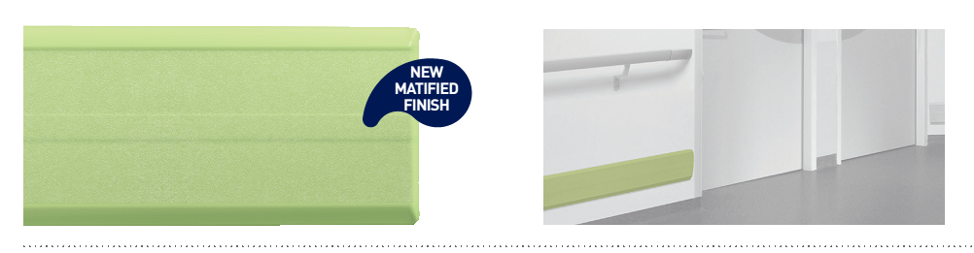


SPECIFICATION

LINEA’PUNCH NEO
WALL PROTECTION RAIL - 180 MM HIGH

- Description: flat wall protection rail with a central boss (Linea’Punch Neo as manufactured by SPM) from matified and antibacterial PVC achieving Bs2d0 fire rating with solid colour. PVC profile projects 25 mm, is 180 mm high and 2.5 mm thick. It provides a matified surface finish and snap-fixes onto aluminium brackets or continuous aluminium rail (optional) made more robust by an exclusive ‘omega’ shape. A protective film is specified to minimise cleaning before acceptance The upper and lower parts of the profile are smooth, beveled and edged with strengthened lips to hold the profile tightly against the wall and minimise dust traps. Finish is provided by slim beveled and smooth end pieces (16.5 mm wide). This wall protection rail achieves an impact resistance in excess of 110 Joules, i.e., an impact of more than 320 kg travelling at 3 kmh.
- Environment: no heavy metals and no substance potentially subjected to any REACH restriction are used in its manufacture, nor PBT/BPA. The calcium-zinc thermal stabilisation process is used. The emission level of volatile substance in inside air has been tested according to ISO 16000-6 and is very low (A+) according to the French regulation (23 March 2011 nr 2011-321 Decree and 19 April 2011 Order). 100% of the product are recyclable.
- Colour: selected by architects from manufacturer’s standard range.
- Installation method: recommended height of protection rail centreline 0.80 m above floor level for mid-level wall protection or on top of the skirting for low level wall protection. Snap-fixes to aluminium ‘4-point’ brackets spaced at 0.75 m centres or continuous aluminium rail (optional).
